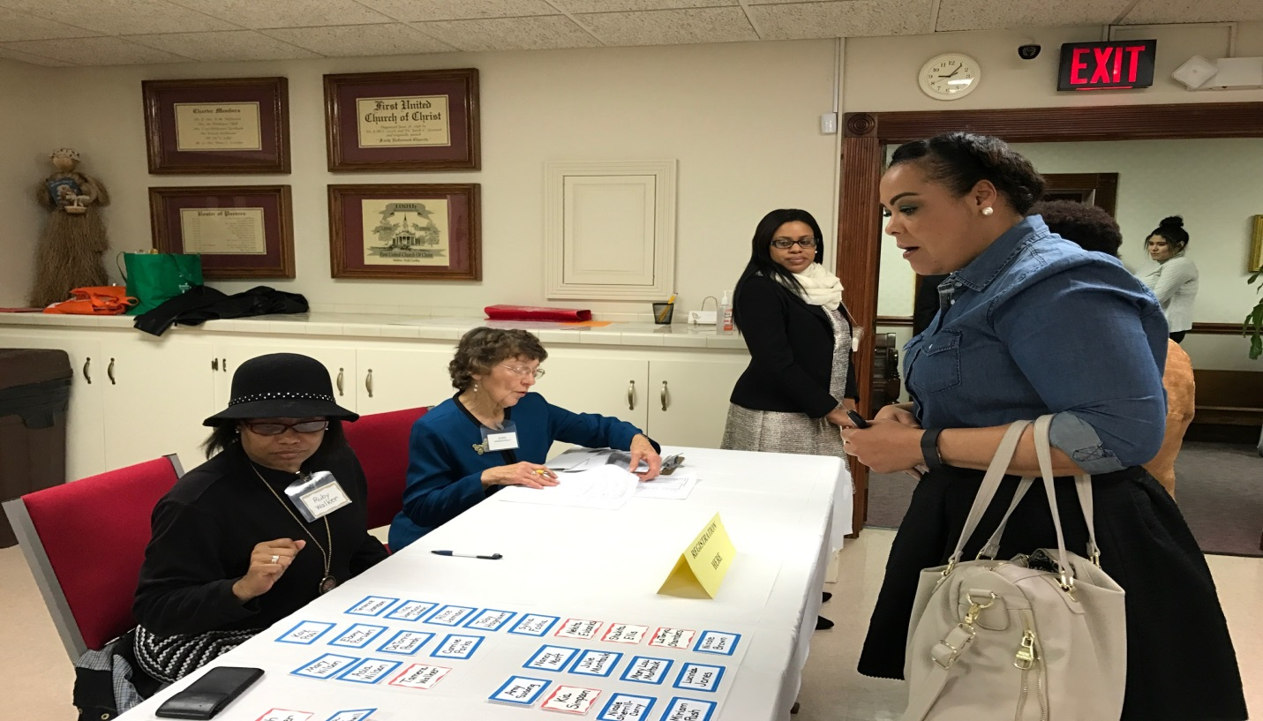

AAUW Members: Ruby Walker (Black hat) and Eileen Hanson-Kelly register guests as they arrive. Vincia Benjamin-Miller looks on as Tammara Walker registers.

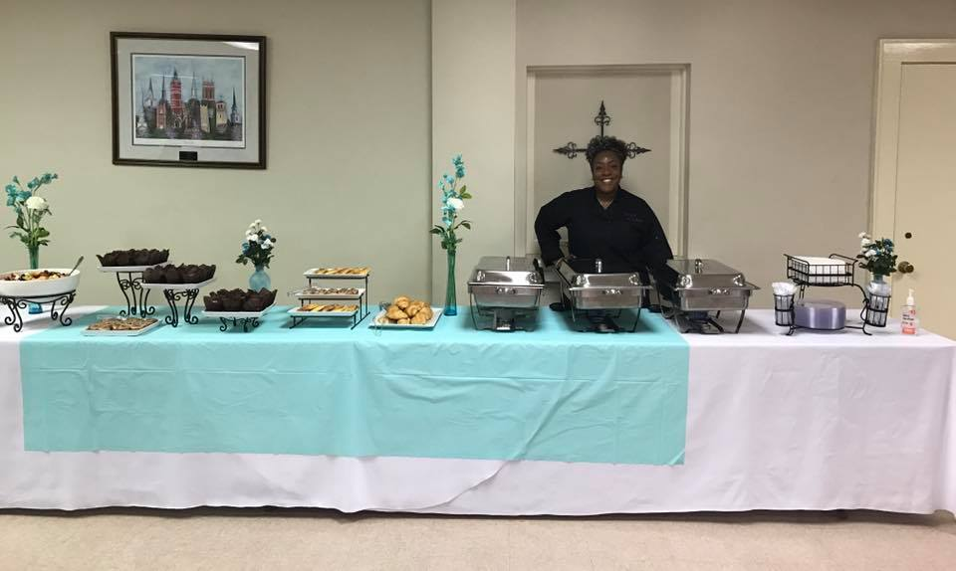
Ms. Kelly Vanager, getting ready for the 2017 AAUW Annual Brunch crowd. She is the owner of Kellys’ Kitchen.

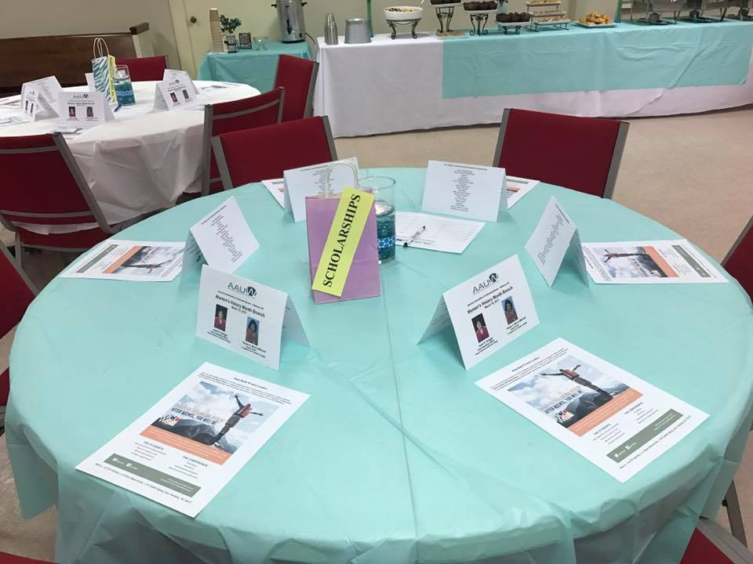
The beautiful tables are decorated and ready for our members and guests.

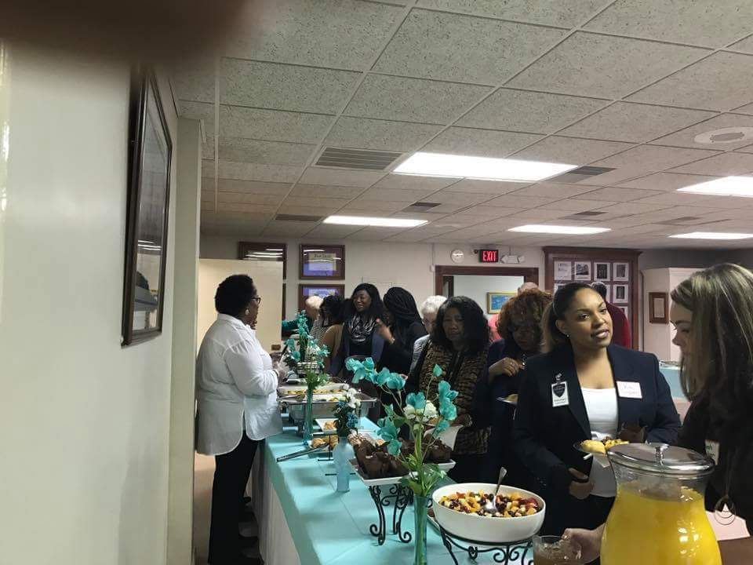

Ms. Chambers serves members and guests as they line up to eat brunch, such a colorful and delicious brunch.

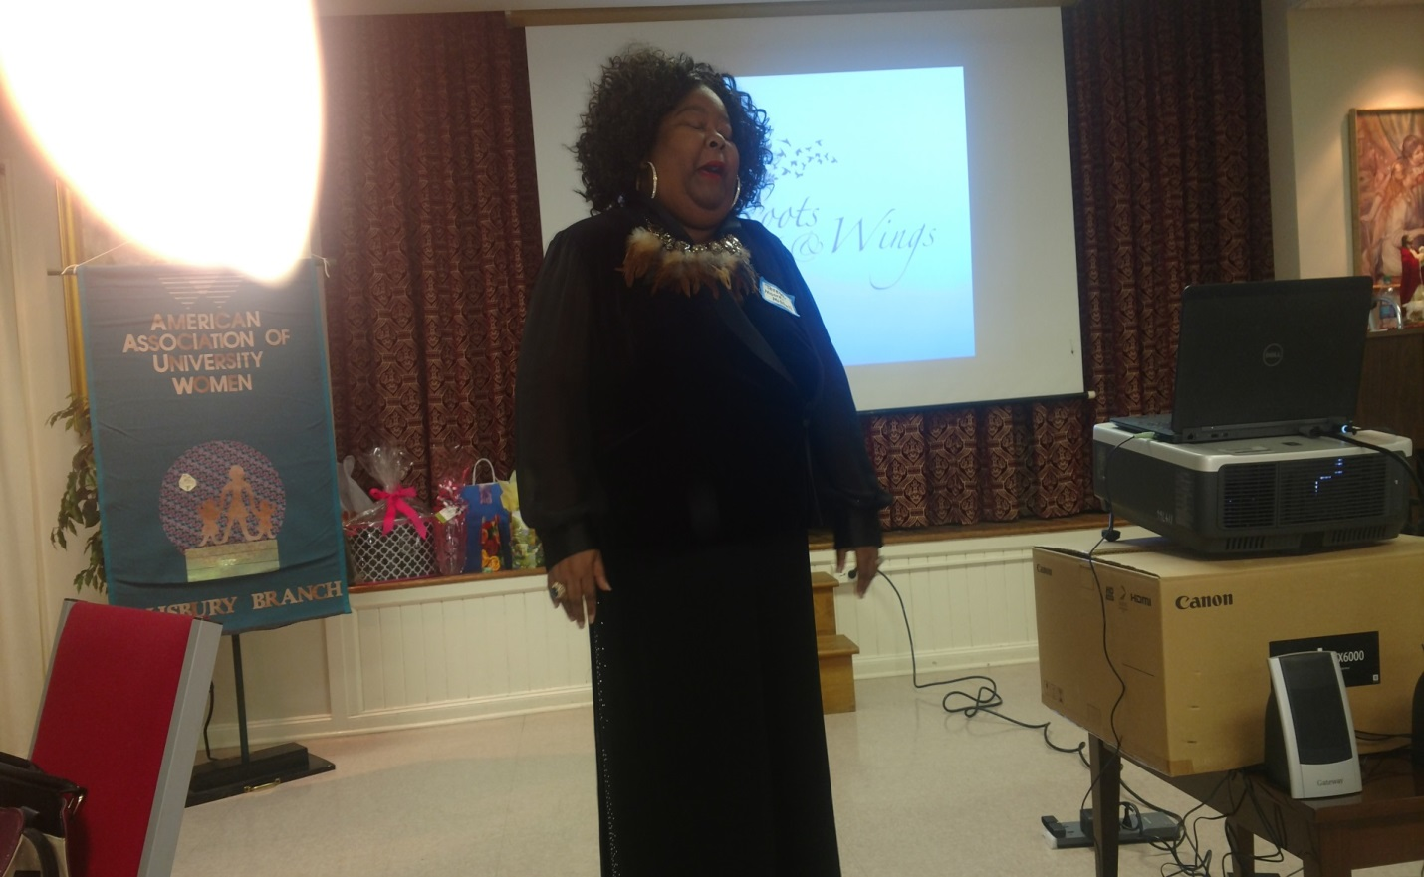

AAUW Salisbury branch president, Dr. Carol Cody introduced Teresa A. Moore-Mitchell a renowned vocal artist who opened with inspiring music. Her rendition of “Witness” and “He’s Got the Whole World in His Hands” stirred the audience of 50 women and men of all ages. Moore-Mitchell is a vocal instructor at both Livingstone and Catawba Colleges, and has performed throughout the country and internationally for over 29 years.

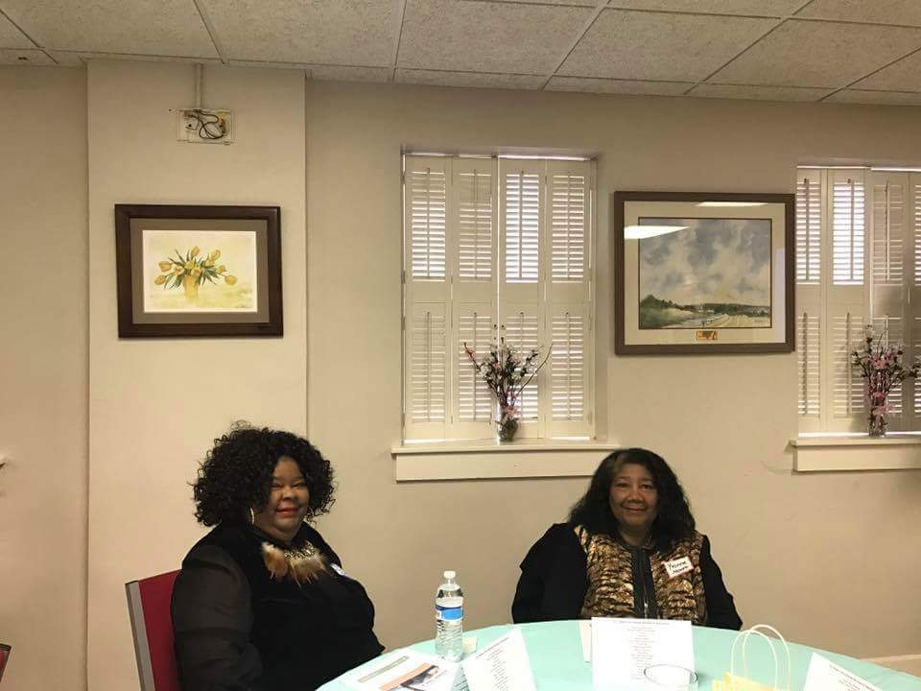

Teresa A. Moore-Mitchell and her Mother, Ms. Yvonne Moore.

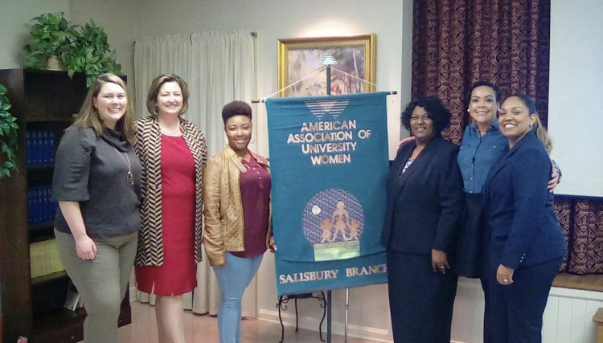
The people in the photo are: (Left to Right) Sarah Walker, Janet Spriggs, Shakita Ellis, Dr. Trueblood, Tammara Walker and Shakia Simpson.
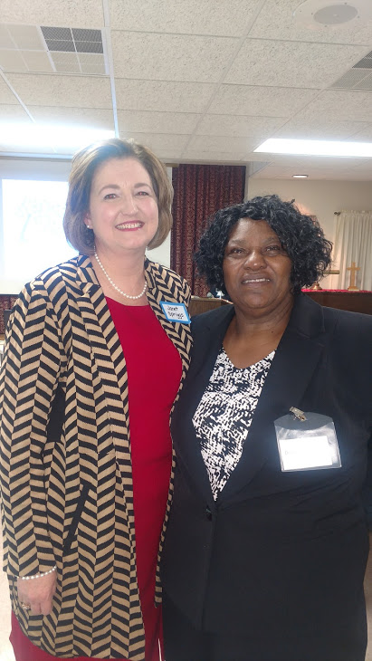
Our guest Speaker
Mrs. Janet Spriggs
AAUW Vice President of Programs Dr. Patricia Trueblood

Mrs. Janet Spriggs, is the Chief Operating Officer at Rowan- Cabarrus Community College, she gave a dynamic video presentation on her theme, “The Roots to Grow and the Wings to Fly: Changing the World with the Power of Education.
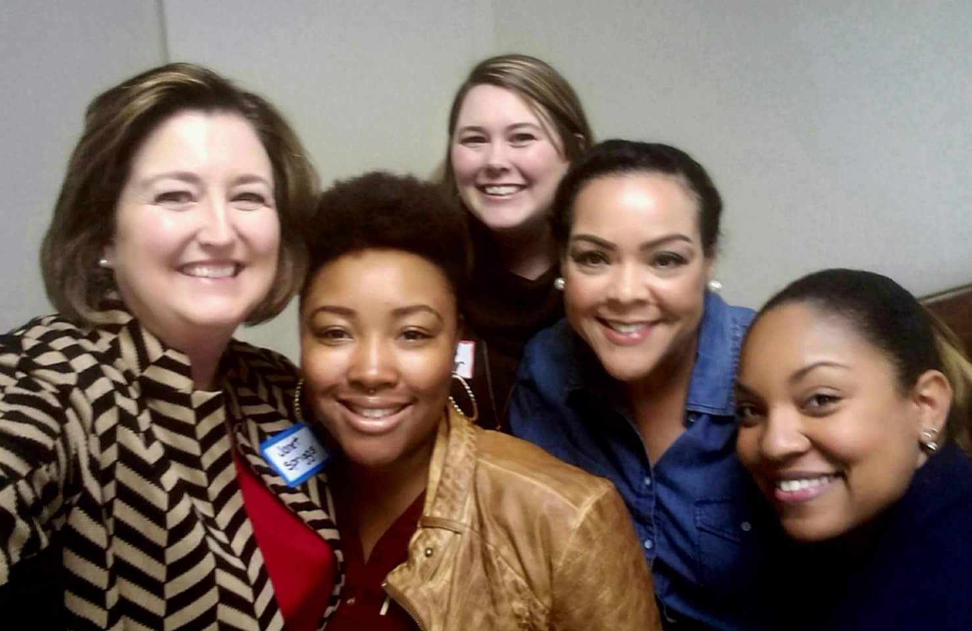

Our guest speaker: Mrs. Janet Spriggs, (Left to Right) Shakita Ellis, Sarah Walker, Tammara Walker, and Shakia Simpson
Sarah Walker is Director of Governance, Foundation and Public Affairs at RCCC. The other ladies are students at RCCC.

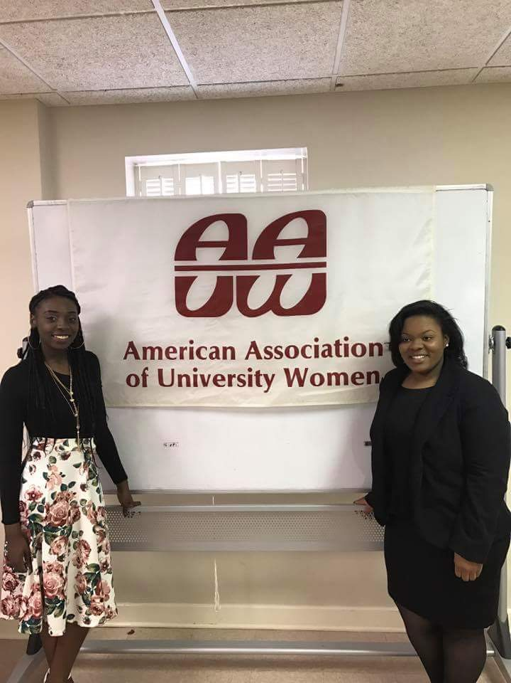

Congratulations to Renae Moses and Tiara Arnette. They will represent AAUW and Livingstone College in Maryland for the Annual National Conference for College Women Student Leaders (NCCWSL) Conference.

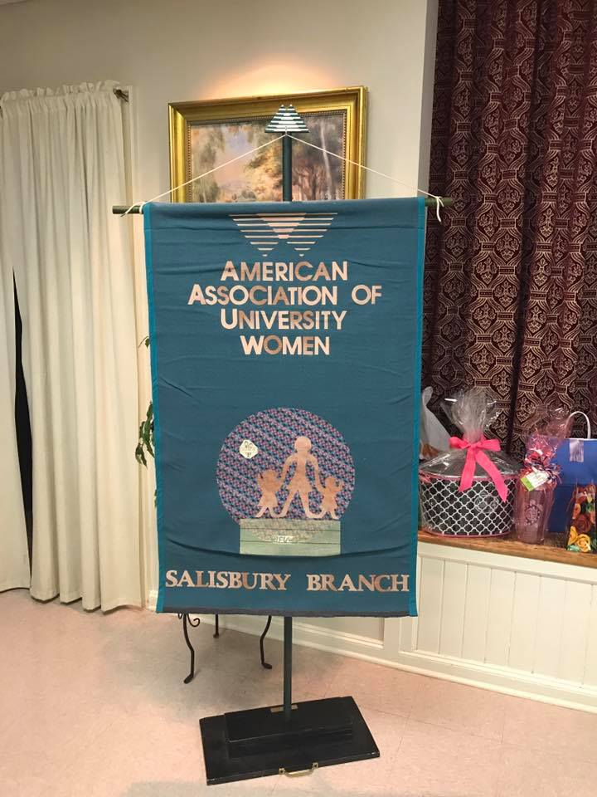
AAUW Salisbury Branch, would like to thank everyone for their participation and contribution. We hope to see you next year!

